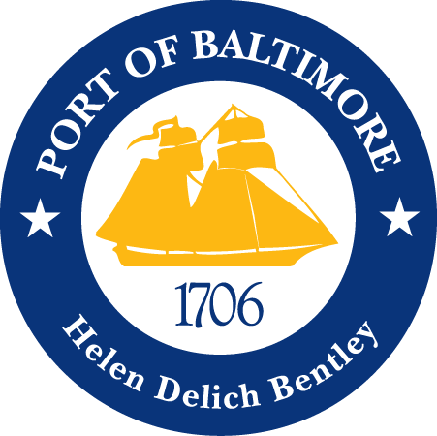

2018 AAPA COMMUNICATION AWARDS SUBMISSION
Port of Baltimore
Port of Baltimore App
Classification 7: Miscellaneous
Port Category: 2
Summary:
The Port of Baltimore (POB) experienced a record year in 2017, including an 11 percent increase in containers from the previous record set in 2016. While that is good news, the growth has led to longer truck turn times and a need for another direct communication tool with truckers. The Maryland Port Administration took this as an opportunity to develop a smartphone application. Through massive collaborative efforts, The Maryland Port Administration planned, developed and executed an application suited for trucking needs.
1. What are/ were the entry’s specific communications challenges or opportunities?
The Maryland Port Administration (MPA) set a goal to effectively and efficiently communicate with the Port’s customers through a technologically based system to keep pace with a tech heavy world. However, communicating with all of the Port customers is a tall order and the scope of the idea needed to be honed to create a more effective form of communication. Multiple MPA departments were surveyed regarding customer relations issues that were being address the most frequently, in search of an area that could be improved by a direct source of information. It was determined that the trucking industry would be best served by an on- the-go tool that could deliver facility information, directions, and real-time updates regarding terminal activity, traffic, and operating schedules in the form of a downloadable application to individual driver’s cell phones.
Once the decision had been made to provide an app to the trucking industry in and around the Port of Baltimore, factors such as platform, capabilities and cost had to be weighed during the development process. Aesthetics, user friendliness, and scope of information were factors taken into consideration for the overall design and presentation. Multiple departments were engaged to narrow the scope of information provided to ensure the target audience was fully engaged and the information provided was relevant and current. MPA’s Information Services Department put together a team to research an array of platforms to find the best fit for the desired capabilities and financial investment. External entities, such as the Maryland Motor Truck Association, were engaged to provide feedback on what the industry would find useful and would elevate the level of communication between the MPA and the industry.
2. How does the communication used in this entry complement the organization’s overall mission?
The mission of the MPA is to increase waterborne commerce throughout the POB to benefit the citizens of State of Maryland. By providing truck drivers with easy to access directions specific to their destinations, updates on terminal activity and real-time traffic conditions, truck drivers are able to navigate our marine terminals more effectively and can plan cargo pick-up and drop-off activities in a more efficient fashion. Assisting the trucking industry in these two ways contribute to more efficient terminal operations and increases the overall cargo throughput to the POB.
3. What were the communications planning and programming components used for this entry?
The POB app is designed to create a direct line of communication and information to the trucking industry in and around the POB in order to assist in the overall efficiency of cargo operations at MPA facilities. The goal is to have an easily accessible application for truck drivers to download that will give them information about accessing MPA facilities, business locations within MPA facilities and where they will receive real time push notifications regarding information directly effecting terminal operations. MPA’s marketing department was engaged to promote the app to the trucking industry via signage throughout our marine terminals, in person meetings with trucking industry leaders, and exposure during shipping industry conferences and exposes. Multiple MPA departments have been engaged in compiling and reporting real time information to be communicated through the app via push notifications and app updates. The application went live August 2017. To date, the app has received 343 downloads and the MPA has transmitted 11 push notifications. While the trucking industry is the primary target audience for the application, the facility information and GPS directional features have been found useful by other port users navigating the Port of Baltimore.
4. What actions were taken and what communication outputs were employed in this entry?
The project was spearheaded by the Maritime Commercial Management Department (MCM) in conjunction with Marketing, and Communications and was overseen by the three Directors. Once the Directors chose a target audience for the application, a budget was created, and both platform and content for the application became a dual focus for the project. Two teams were engaged to research and finalize the next steps. The first team consisted of three people from the Information Services Department (ISD) researching software, and categorizing capabilities that best fit the goals for the project, such as data tracking, push notifications, content editing features, user friendliness, and cost. The team presented two platforms to the Directors and AppMachine was chosen. The second team consisted of three people from the Marketing Department, two people from the MCM, and two people from the Communications Department to compile content by using existing MPA resources, reaching out to port customers for input, and collecting new information. Prior to beginning the POB app project, the MPA produced a hard copy map targeting the trucking industry. The map was used to start the basis for compiling information relatable to the trucking industry. The Marketing people reached out to current port customers to survey truck drivers verbally for information that would be useful on the road. The Property people compiled and organized current facility and customer information to be loaded into the application. The Communications people worked on design, aesthetics, and organization for user friendliness. When content and platform were determined, the teams worked together to input all the data into the application and launched for user testing. The first users were the Directors who downloaded, reviewed, and submitted feedback to the teams. The teams worked together to address all the feedback, then released the application to a second group of users which consisted of specific leaders in the local trucking industry. Feedback was again given, addressed, and the app was then released for public download on both Apple and Android operating systems. Currently, the Marketing team is promoting the application, the MCM team is updating and increasing port facility information, and the Communications team is responsible for sending real time push notifications regarding port conditions.
5. What were the communications outcomes from this entry and what evaluation methods were used to assess them?
When professionals in the trucking industry were first verbally contacted about the idea of an application specifically targeted to assist them with navigating the POB, the feedback was entirely positive. Assistance from those professionals with the development of the application and testing has been enthusiastic and has not only improved the quality of the application produced, but has strengthened and improved communication between the MPA and a major industry servicing the POB. Though many of the processes used in the creation of the application were of an informal nature, and mostly on a verbal level, the final product has more than helped the MPA meet the initial goal of better communication with port customers in a more technologically advanced way. Through the development and success of this application the MPA hopes to launch a more robust presence in today’s age of technology.

